**Assignment No - 02**

**1.Create text table of sub-category & profit.**

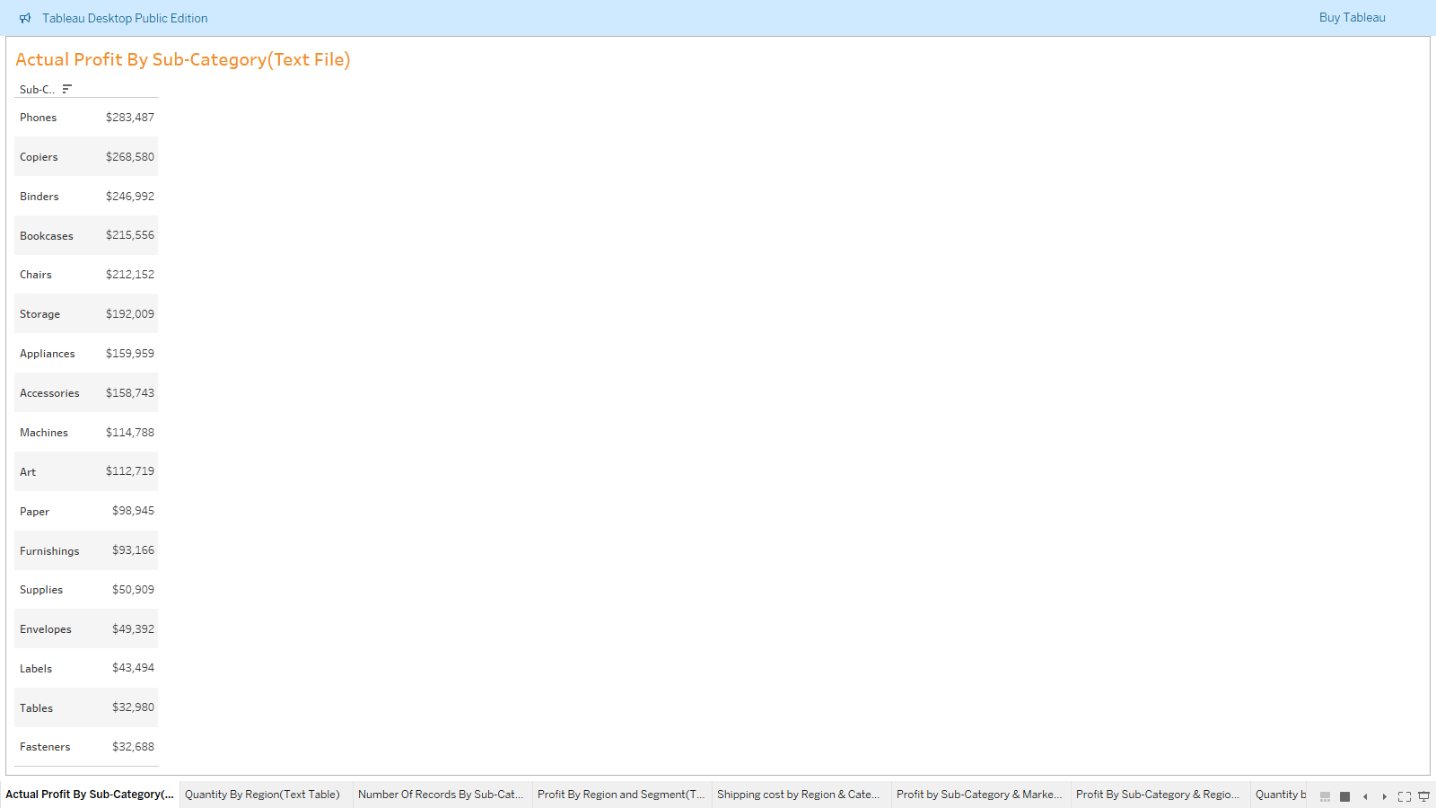

**2.Profit by Region & Order Priority (Highlight table)**

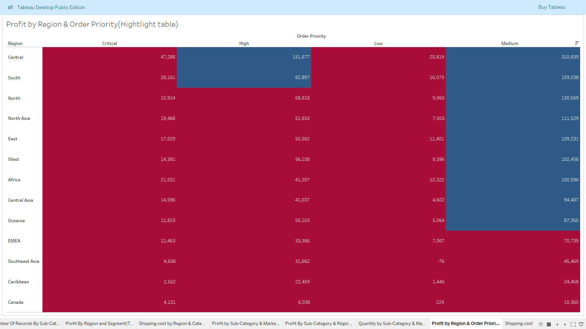

**3.Profit % by Category (Pie chart)**

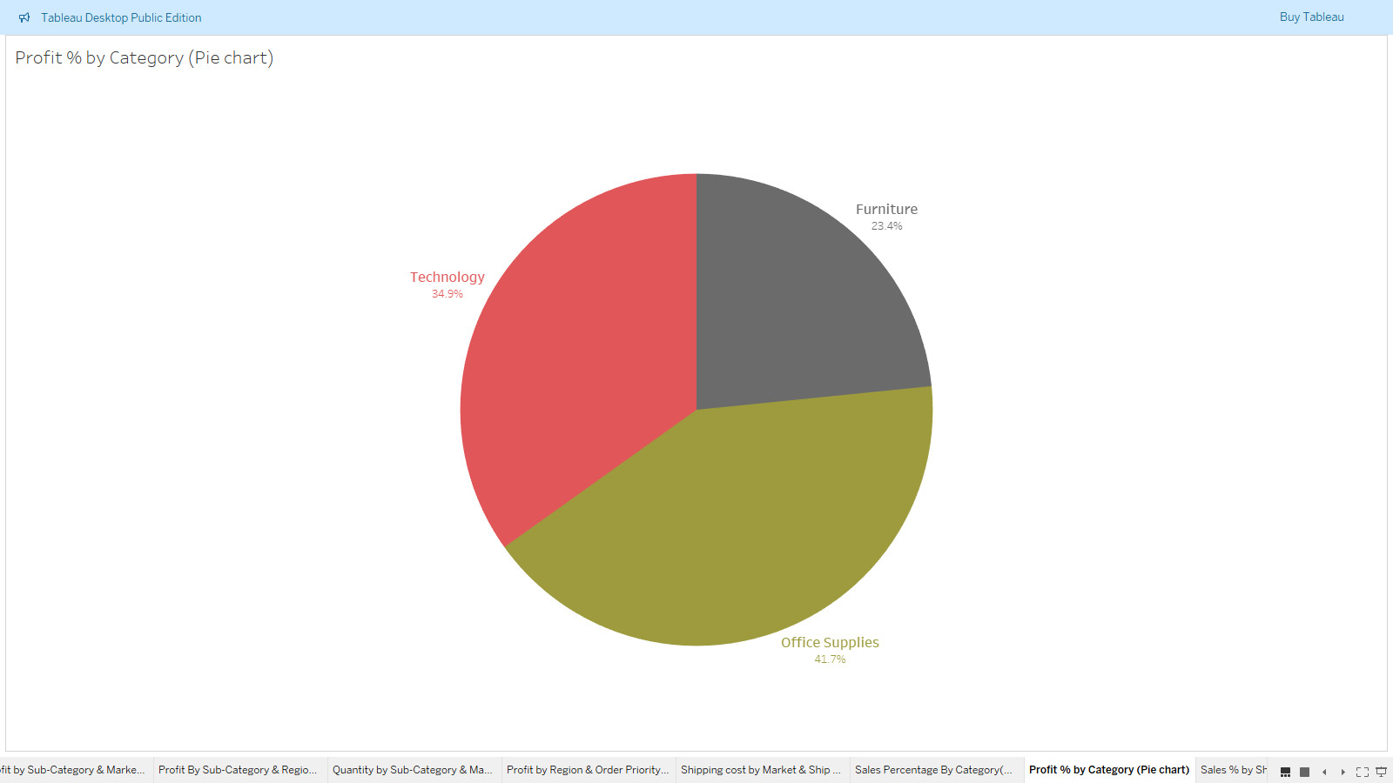

**4.Sales % by Ship Mode (Pie chart)**

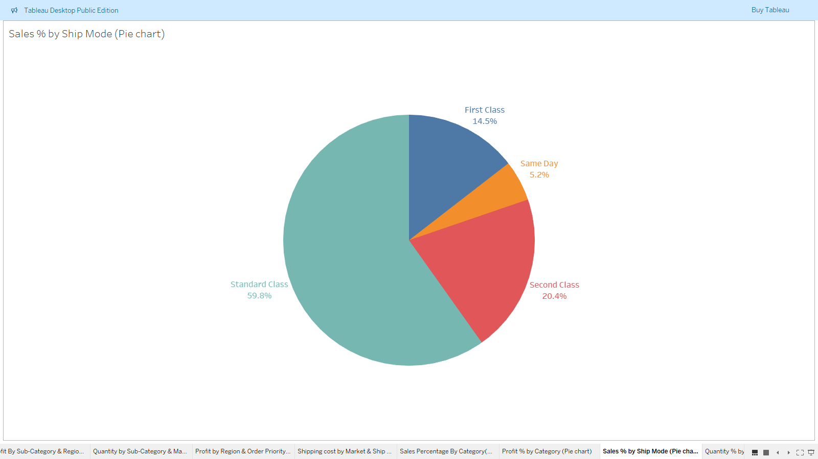

1. **Quantity by Sub-category (Bubble chart)**

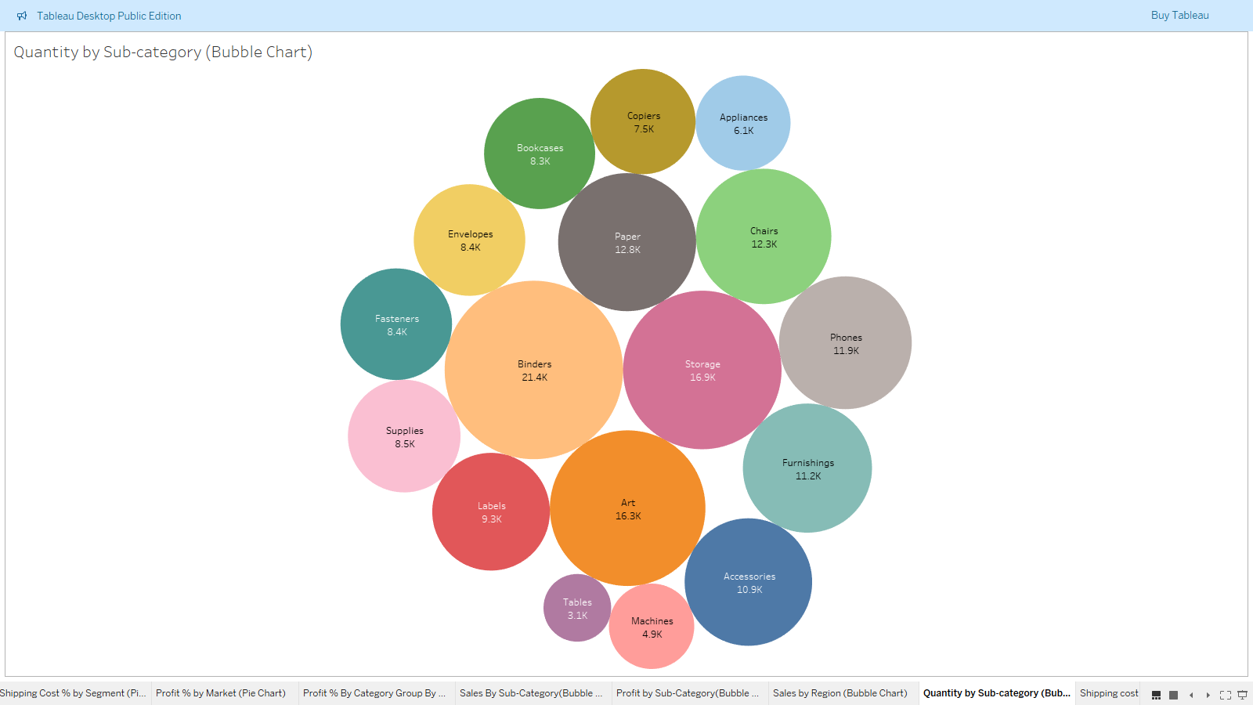

**6. Create treemap of count of products by Market.**

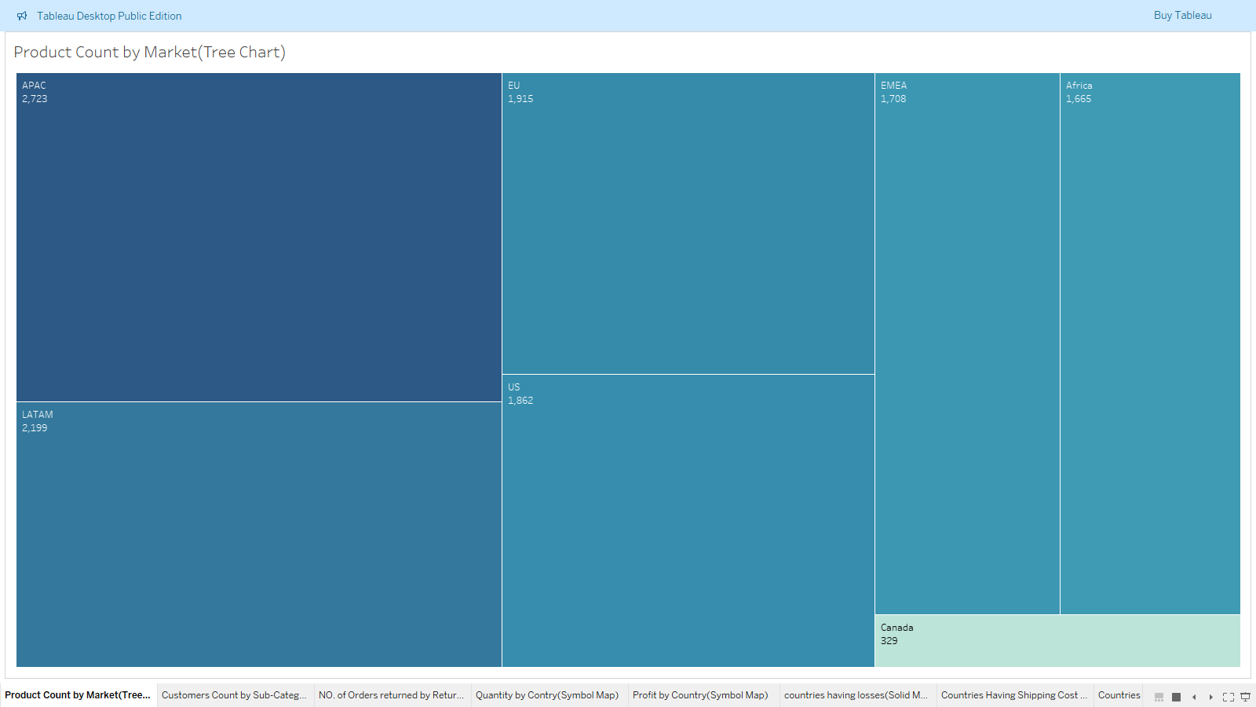

**7.Quarterly Quantity for each year (Discrete line)**

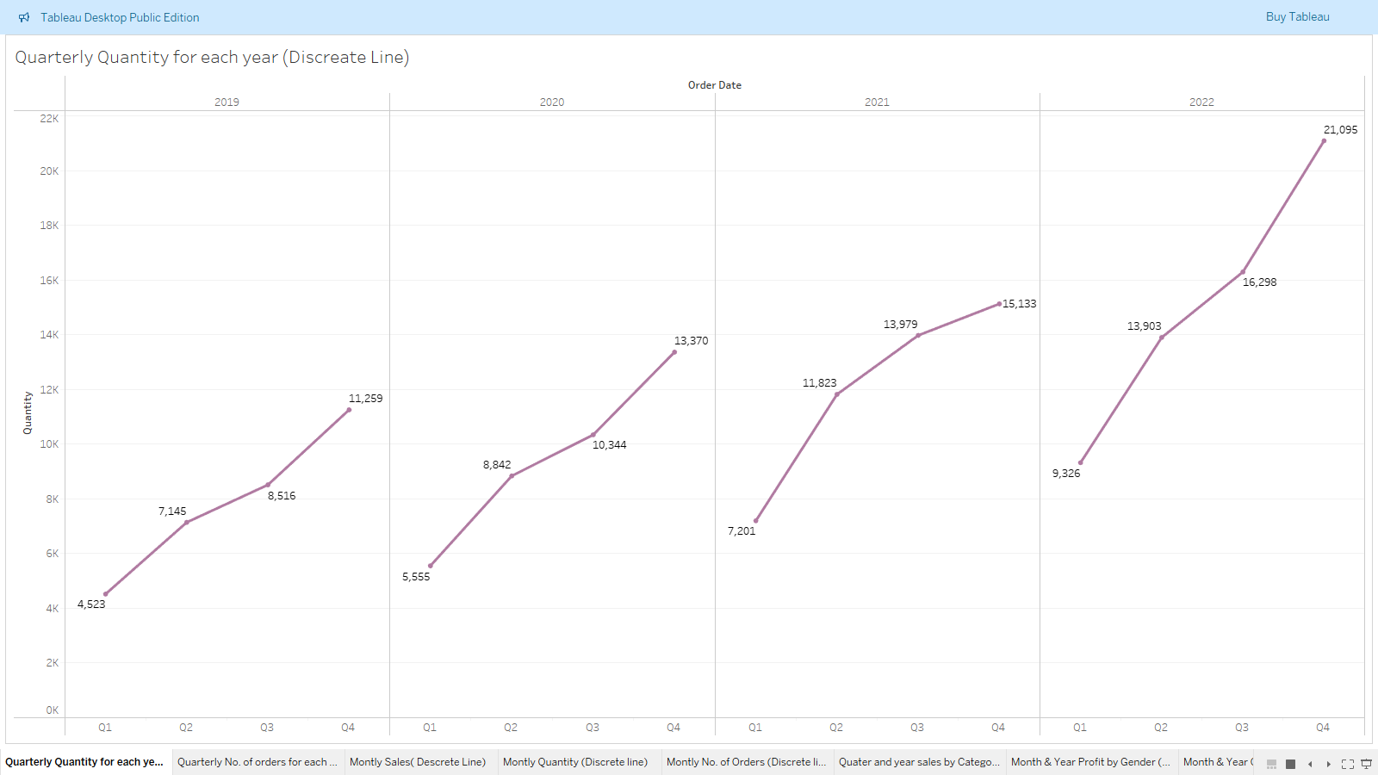

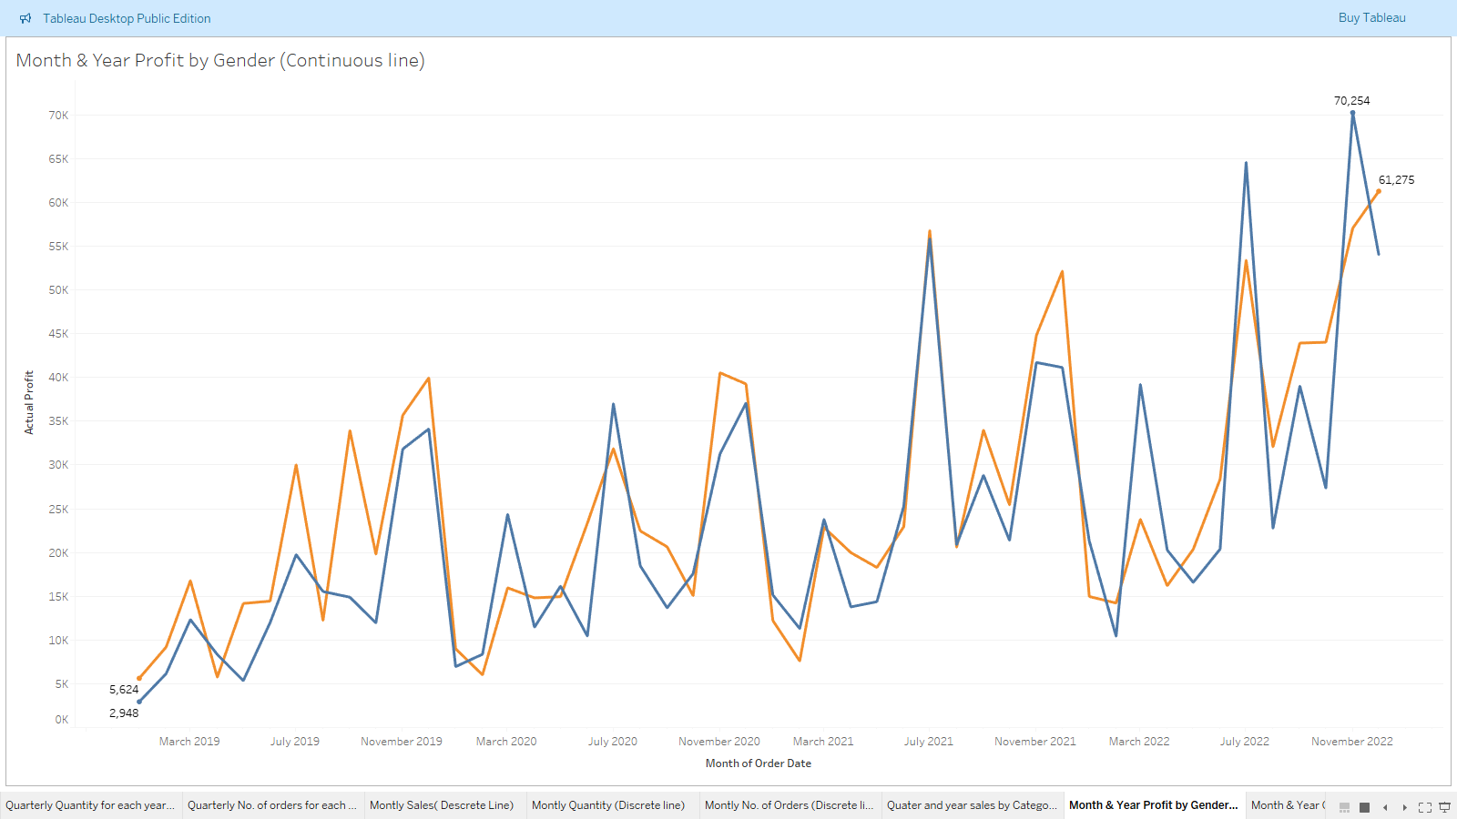**8.Month & Year Profit by Gender (Continuous line)**

**9.Quarterly No. of customers for each year (Discrete area)**

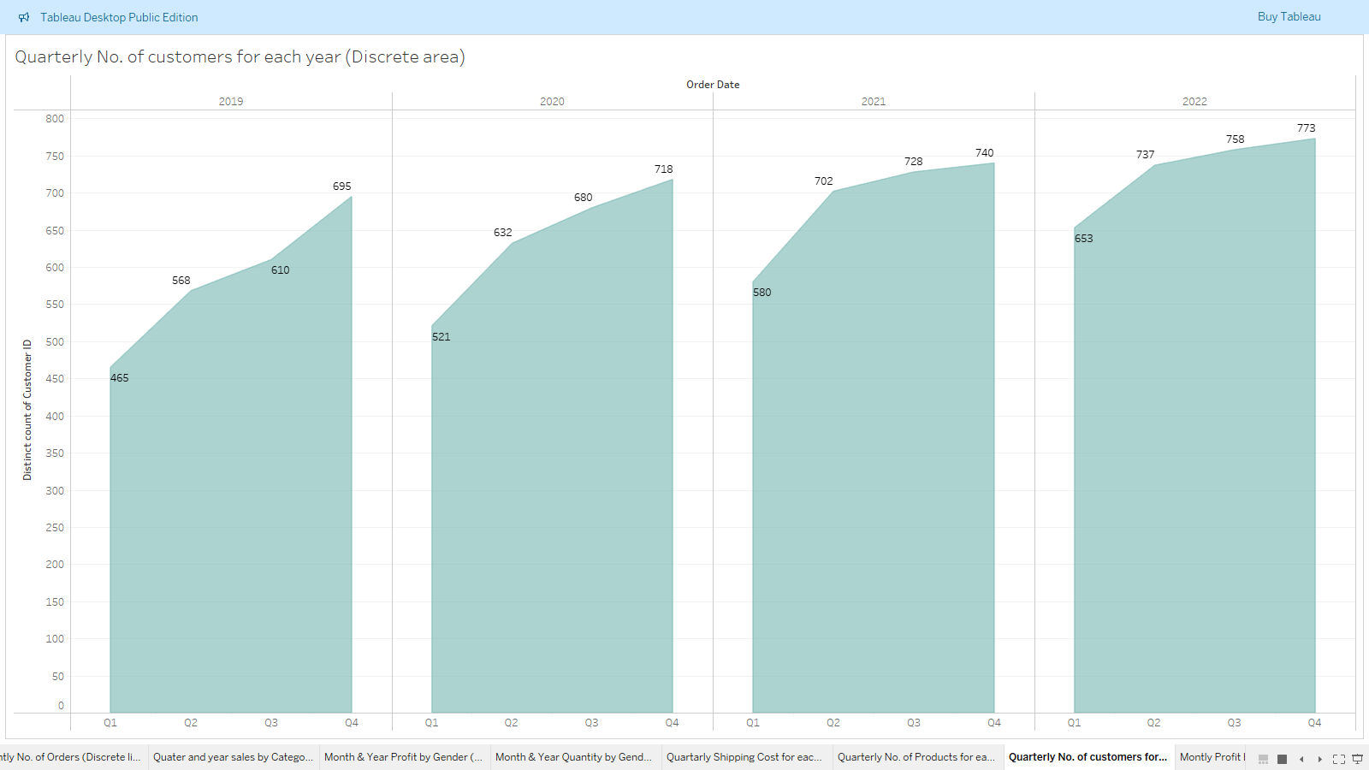

**10.Monthly No. of Orders (Continuous area)**

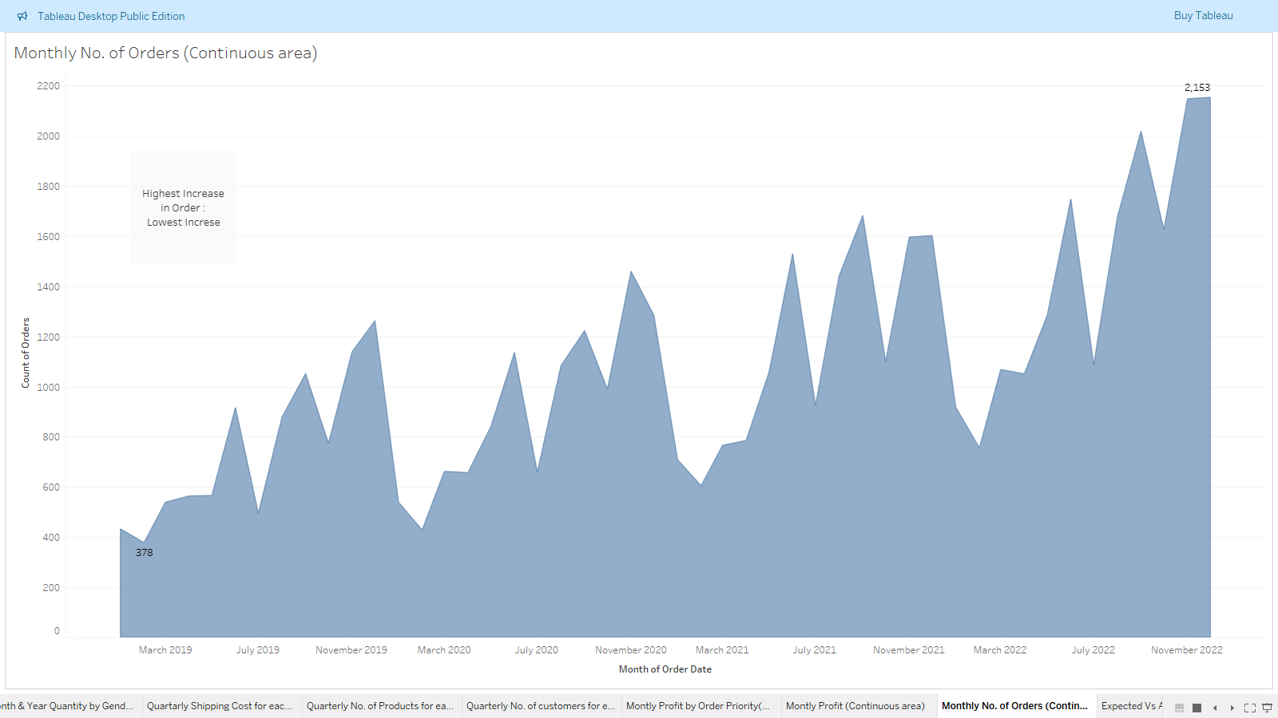

**11.Create Solid map using State field and Profit. Apply following filters-**

**a) Country - select US**

**b) Ship Date - select Month only**

**Make title dynamic. Show the solid map in two colors - Green & Red (positive vs negative)**

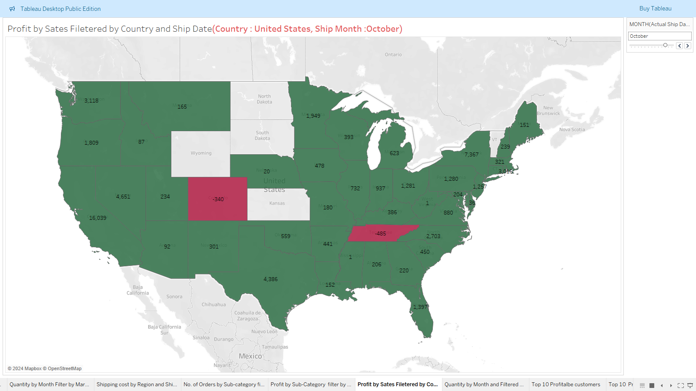

**12.Build continuous monthly quantity line chart.**

**Apply these filters and show on right side-**

**a) Segment**

**b) Market**

**c) Category**

**d) Ship Mode**

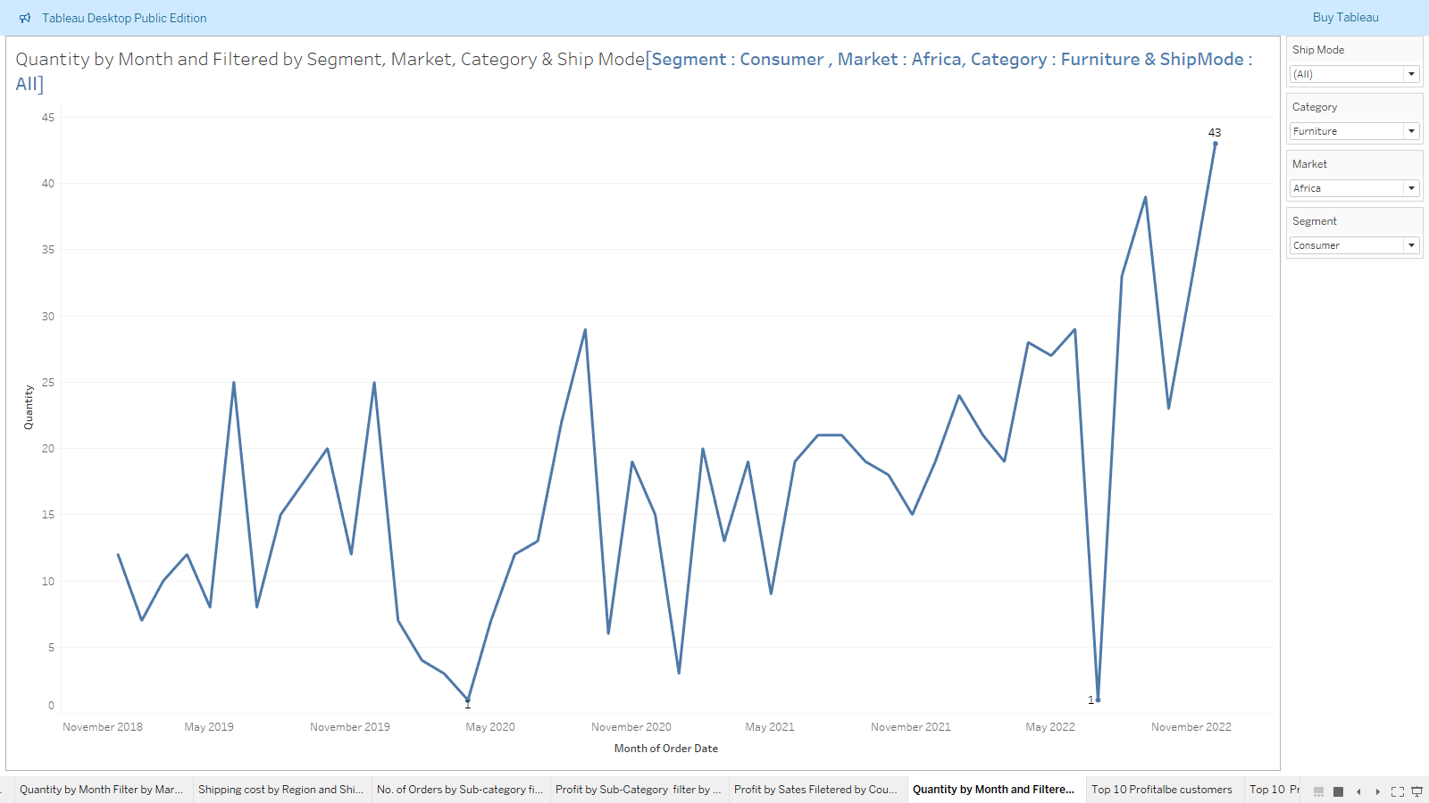

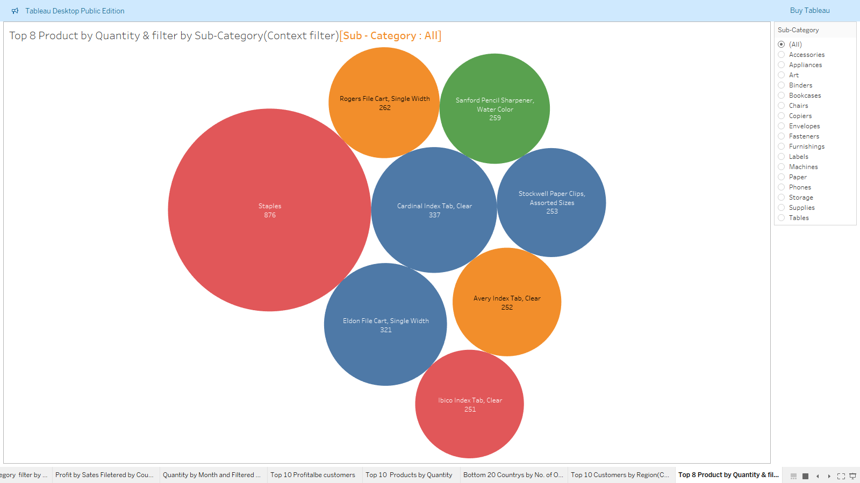**13.Build bubble chart using Product name & quantity. Show only top 8. Apply sub-category filter and set it as context.**

**14.Create set no. 1 for top 5 countries by profit. Create set no. 2 for bottom 5 countries by profit. Then combine them together in set no. 3**

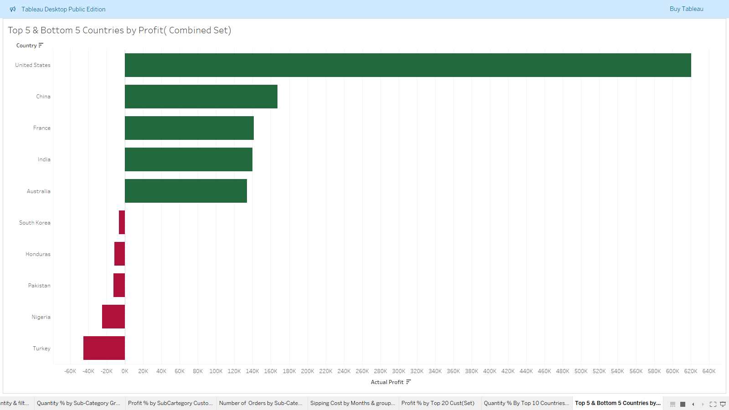

15.**Create treemap of region & no. of returned orders**

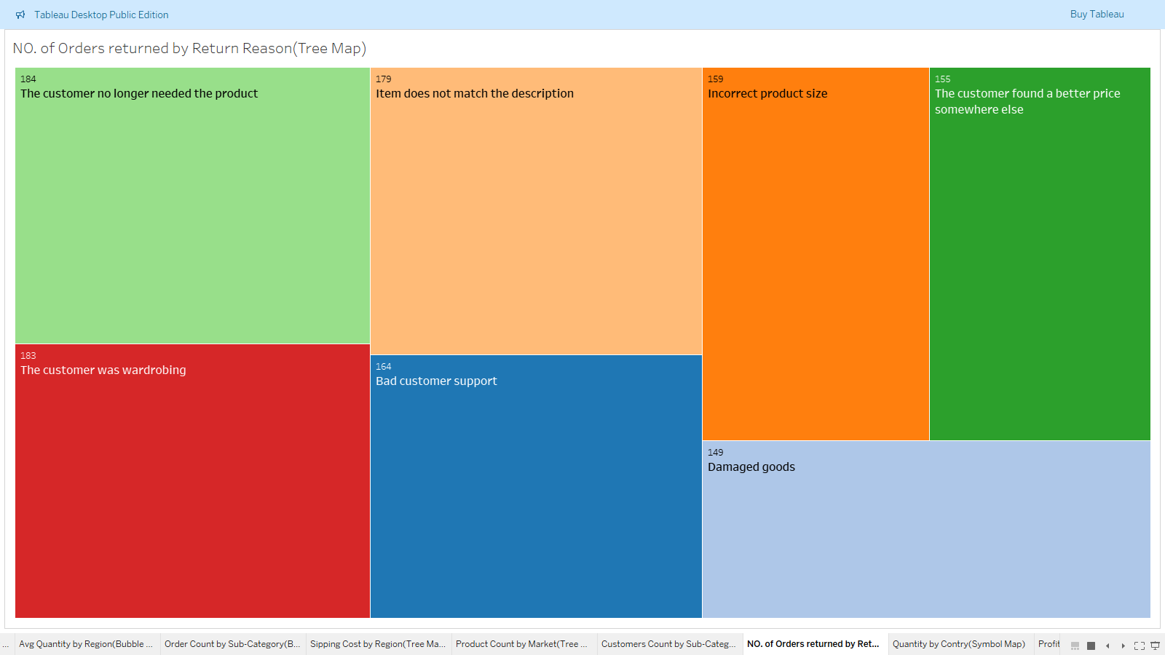

**16.Create monthly forecasting for 15 months for no. of orders.**

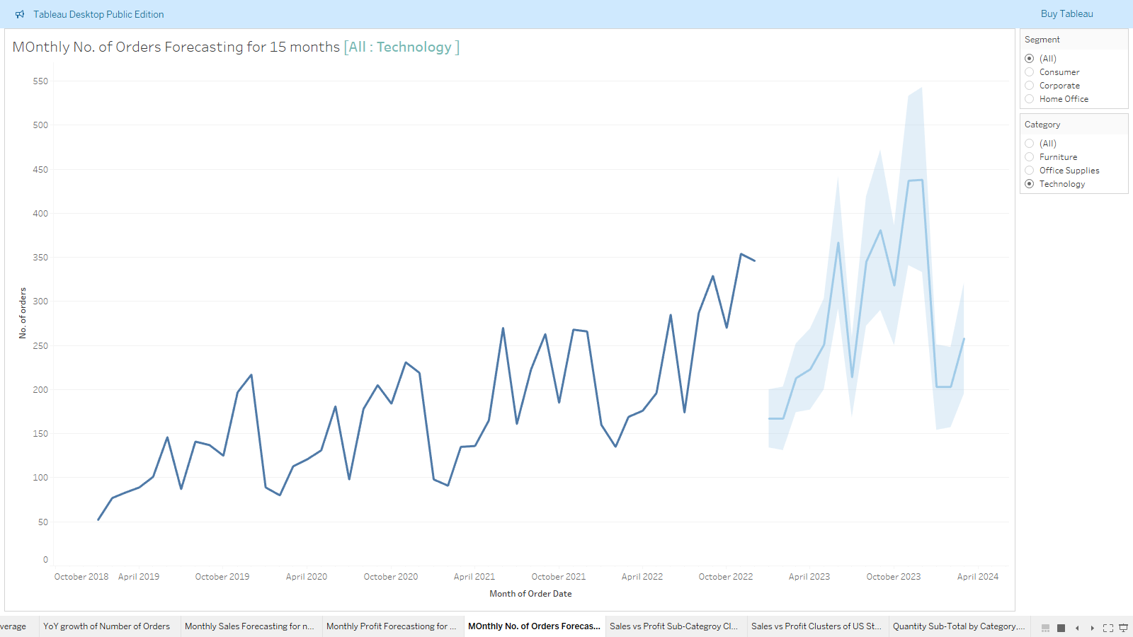

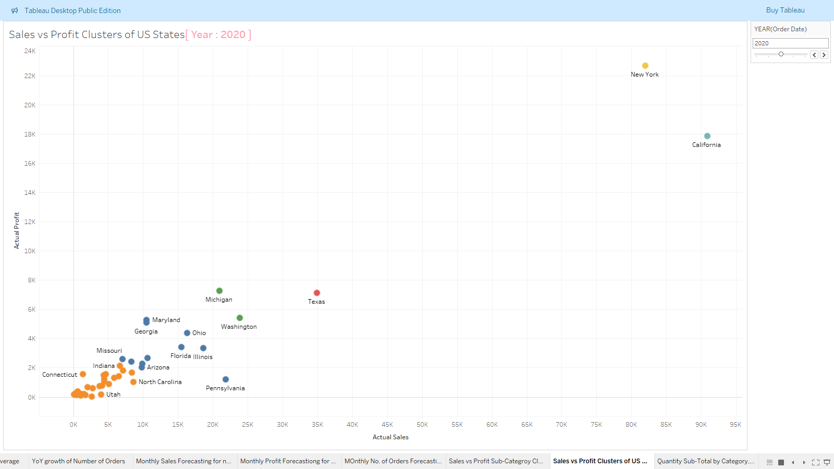**17.Create scatter plot of sales vs profit using State and add Country to filter. Set country to US. Then create clusters of these US states.**

**18.Region & Monthly Profit Ratio Dashboard**

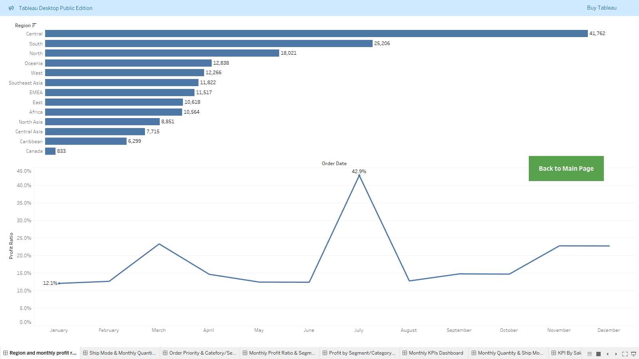

1. 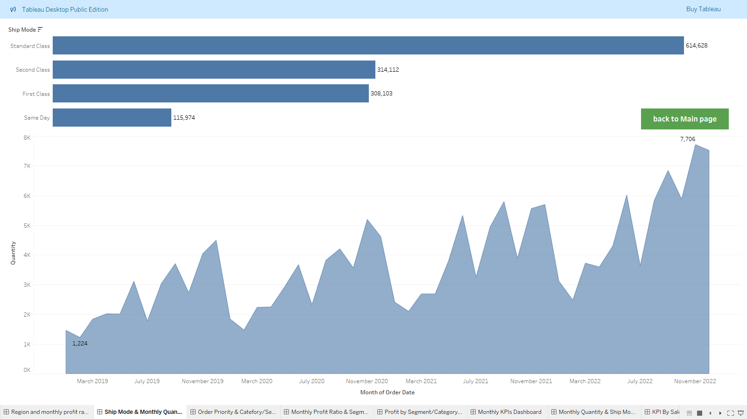**Ship Mode & Monthly Quantity Dashboard**

**20.Monthly Profit Ratio & Segment/Order Priority Dashboard**

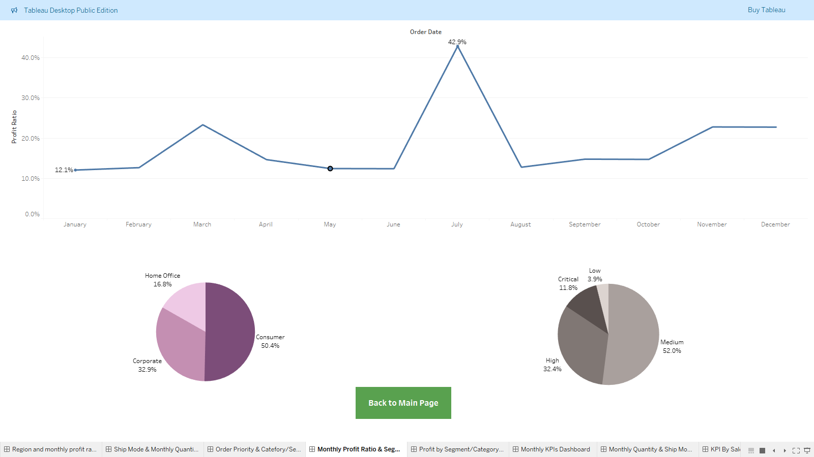

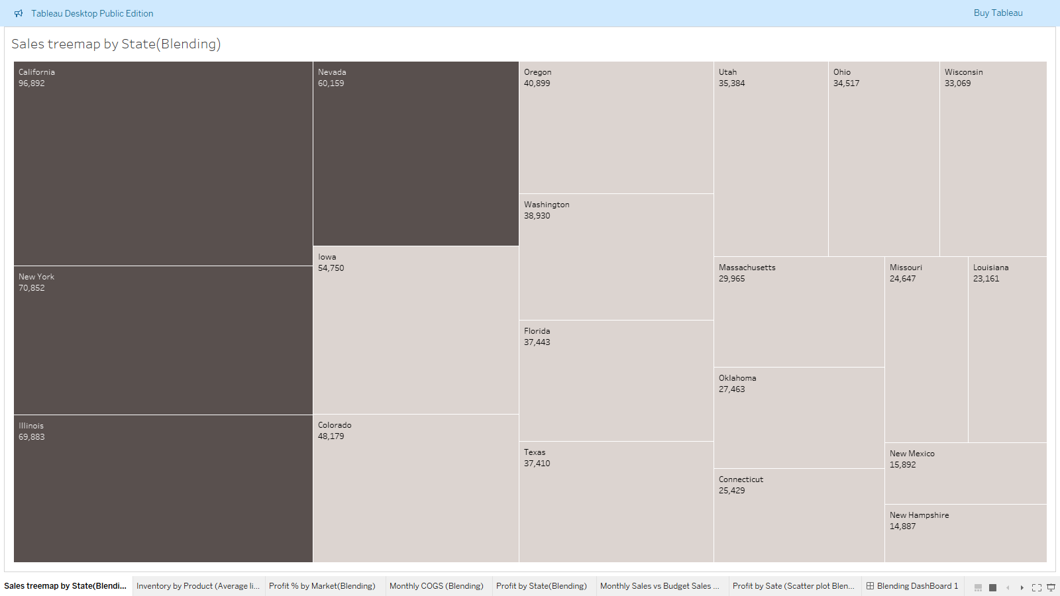**21.Sales treemap by State (Blending)**

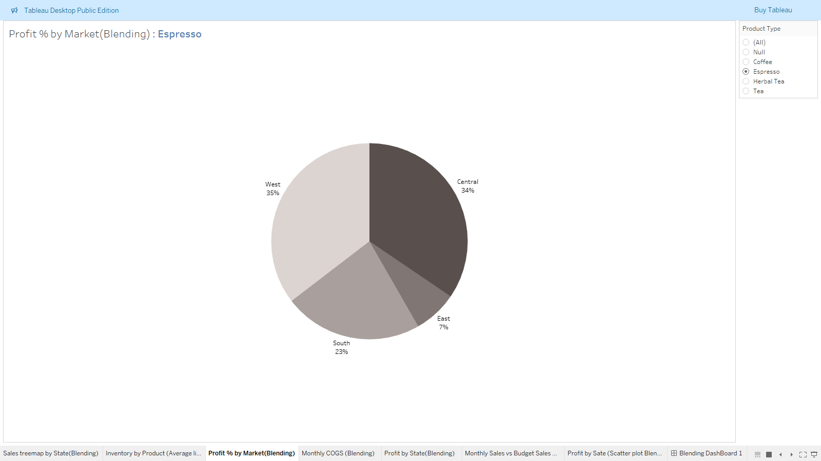**22.Create pie chart using Market field & Profit field. Show % on pie chart.**

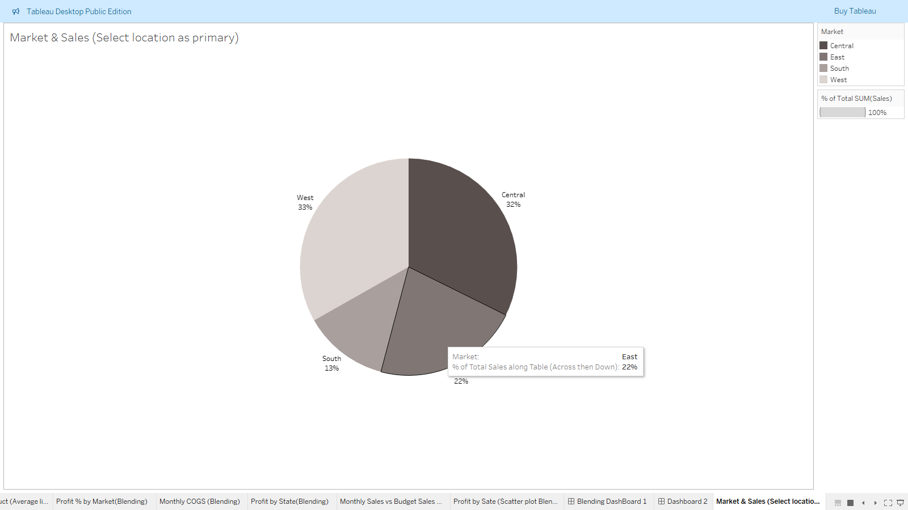**23.Create Pie chart using Market & Sales. (Select Location as primary)**

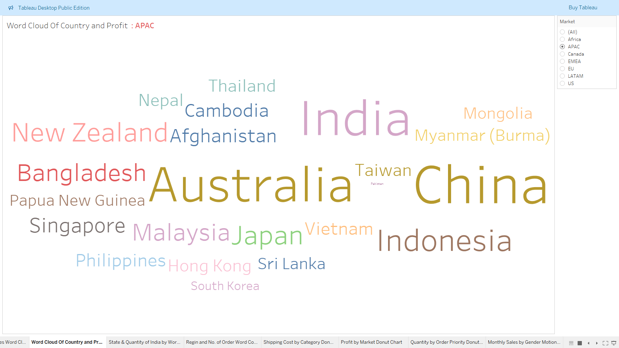**24.Build word cloud of Country & Profit. Add Market to Filter.**

**25.Monthly Profit by Region Sparklines (Add filters - Category & Ship Mode)**

